Module Synthetic DataGenerator
User Tutorial

Step 1: Generate a New Dataset or Use an Existing One
“Module Synthetic DataGenerator” allows you to modify existing datasets, or generate a new synthetic dataset.

Use Existing Dataset
- Select “Open Datafile…” command from the “File” category in the menu bar.
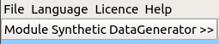

- In the opened file dialog, navigate to a folder, containing .data and .data.json files.
- Open a dataset of your choice. As a result, module should look something like this:
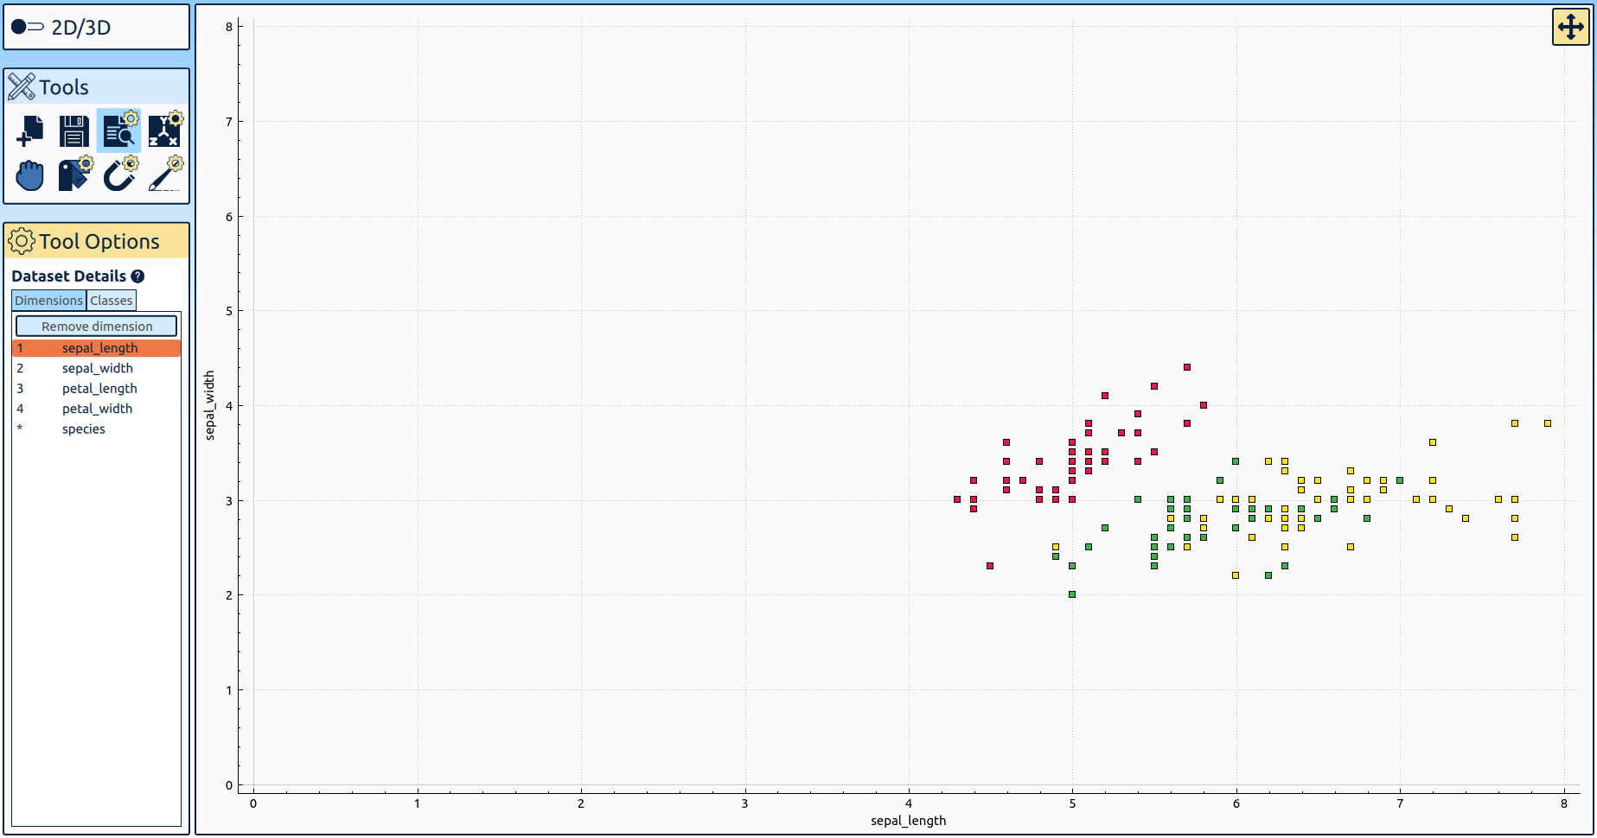

Generate a New Dataset
- Click “Generate Dataset” icon in “Tools” menu.

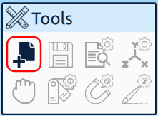

- Specify dataset’s parameters in the opened dialog and click “OK”.
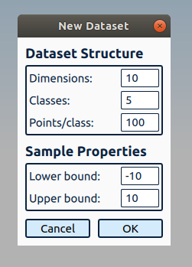

- As a result, the module should look something like this:
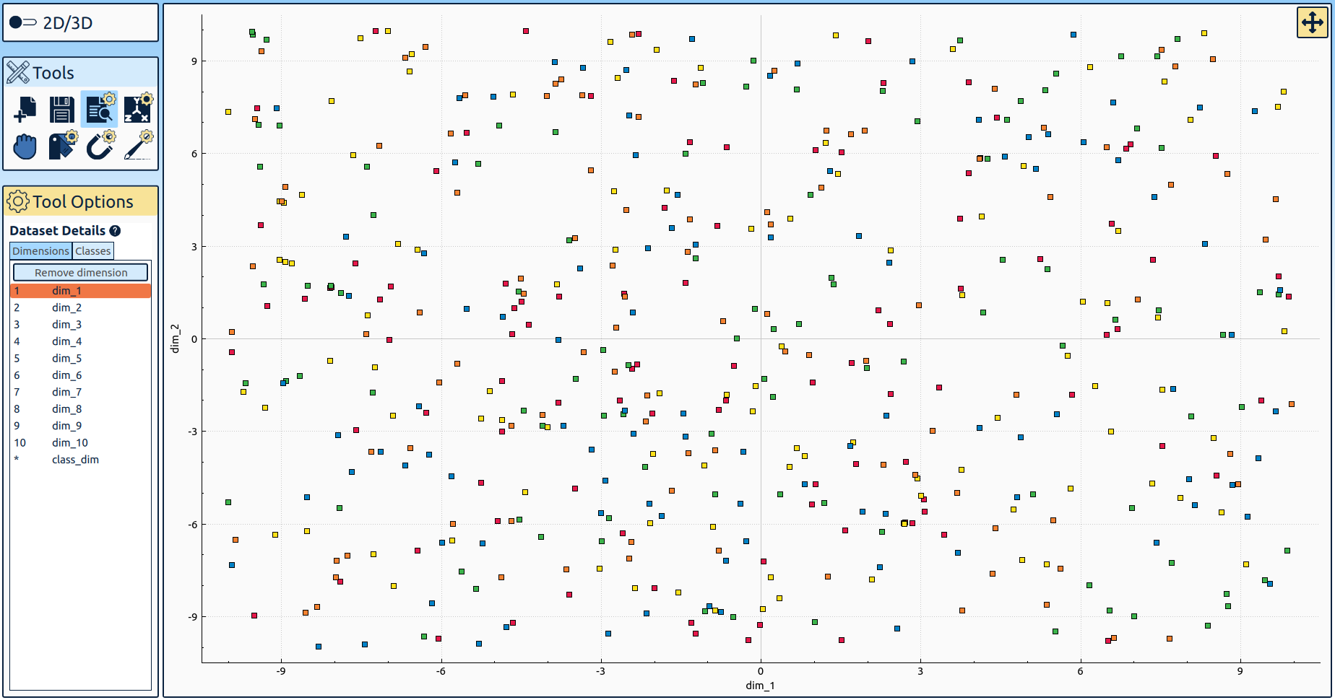

Step 2: Inspect Dataset’s Structure
“Module Synthetic DataGenerator” provides several tools for inspecting dataset’s structure.

Overview of Dataset’s Dimensions and Classes
- Click “Dataset Details” icon in “Tools” menu.
- Inspect dataset’s classes and dimensions in “Tool Options” menu
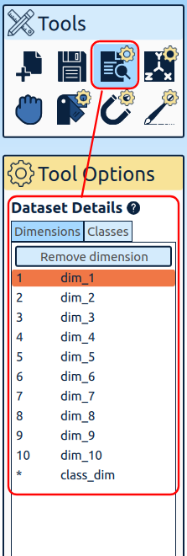
- To rename a class or a dimension, simply select its name, and enter a new one.

Choose Dimensions to Be Visualized

In 2D:
- Click “Inspect Dimensions” icon in “Tools” menu.
- Adjust 2D-Slider in “Tool Options” menu to choose which dimensions will be visualized.
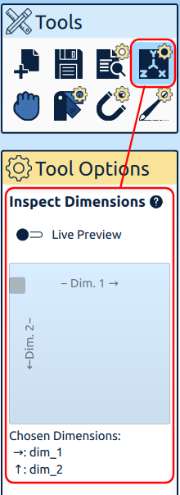

In 3D:
- Click “Inspect Dimensions” icon in “Tools” menu.
- Adjust sliders in “Tool Options” menu to choose which dimensions will be visualized. Slider’s color determines values of which axis will be changed.
The plot will be updated when the slider is released. If “Live Preview” switch is enabled, then the visualization will be updated when the slider’s value is changed.

Adjust Visualization Area

In 2D:
- Drag the plot while holding Mouse’s Wheel to adjust plot’s range.
- Use mouse wheel to zoom in/out of the plot.

- Alternatively, click “Move Plot” icon in the top-right corner of the plot ( ) to show a slider. Use slider to adjust plot’s range.

In 3D:
- Rotate axis cube while holding Mouse’s Wheel to view hidden areas of the plot.
- Alternatively, click “Move Plot” icon in the top-right corner of the plot to show a slider. Use slider to rotate axis cube.

Step 3: Select Datapoints for Interaction

In 2D:
“Module Synthetic DataGenerator” provides 2 ways to select points in 2D:
- Area Selection:
  - Press somewhere on the plot using Right Mouse Button.
  - Move mouse to draw a rectangle.
  - All points inside this rectangle will be selected and highlighted when the mouse button is released.
- Class Selection:
  - Click any point in the plot using Right Mouse Button.
  - All points with the same class as the clicked one will be selected and highlighted.
To clear selection, click an empty spot in the plot using Right Mouse Button.

In 3D:
Selection in 3D happens during the interaction phase which will be discussed in the following.

Step 4: Interact with Selected Datapoints

In 2D:
- Select datapoints you’d like to interact with.
- Click one of the following icons in “Tools” menu:

  - Drag’n’Drop Tool:
    - Drag selected points while holding Left Mouse Button.

  - Assign Class Tool:
    - Choose a new class for selected datapoints using the slider in “Tool Options” menu. To create a new class, slide all the way to the right.
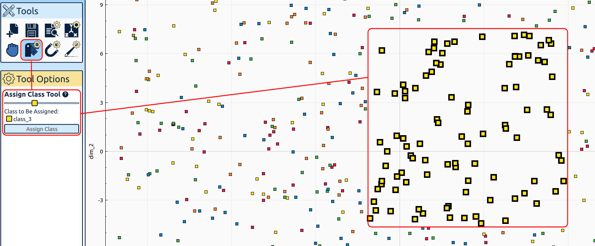
    - Click “Assign Class” button to change class of selected datapoints.
  - Magnet Tool:
    - Set parameters for the magnet (e.g. magnet’s power, should magnet attract of detract etc).
    - Press Left Mouse Button somewhere on the plot to set magnet’s center.
    - Datapoints will be moving to/from the magnet’s center until mouse button is released.
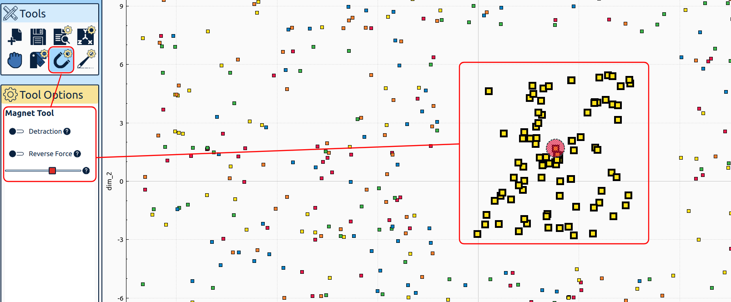
- Strokes Tool:
  - Adjust stroke’s parameters like stroke’s size, intensity and hardness.
  - Draw stroke that describes a new template for selected datapoints.
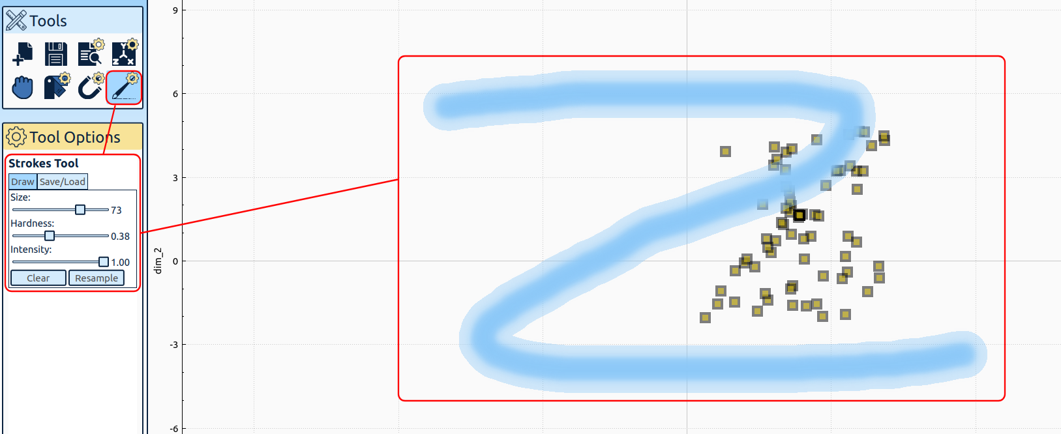
  - Click “Clear” to remove drawn stroke.
  - Click “Resample” to resample points according to new template.
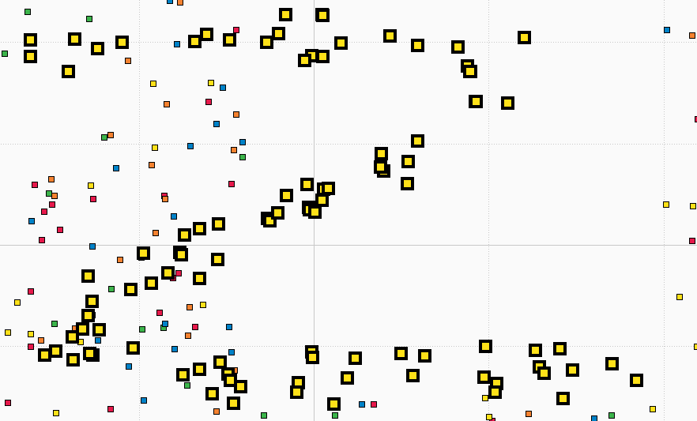
  - Alternatively, you can import an image that describes datapoints’ template. Go to “Save/Load” tab in “Tool Options”, click “Import Stroke” and select an image with resampling template.
  - Furthermore, you can save the template of selected datapoints as an image. Go to “Save/Load” tab in “Tool Options”, click “Save selection as stroke” and save an image with this template somewhere in you system.

In 3D:
- Draw a plane using Left Mouse Button.
- Adjust z-coordinate of the plane using wheel mouse.
- Click “Save embedded plane” to save currently drawn plane.
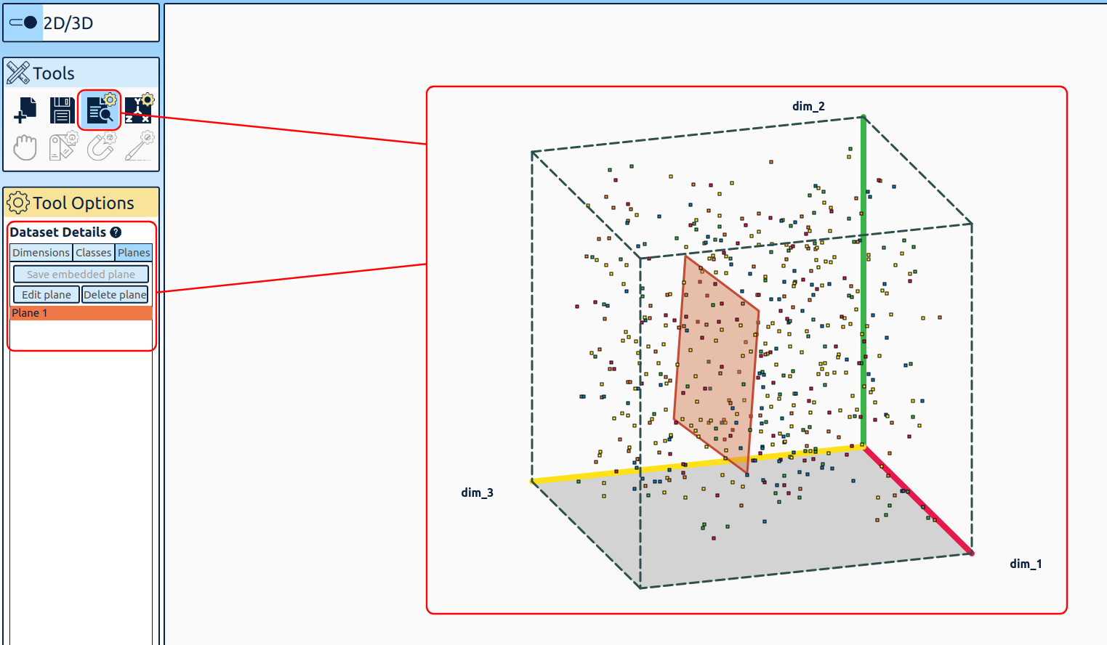
- Click “Edit plane”.
- Draw sampling template like in Strokes Tool in 2D. In 3D, you can additionally specify, which class of points is influenced by this stroke. Use a corresponding slider for this purpose.
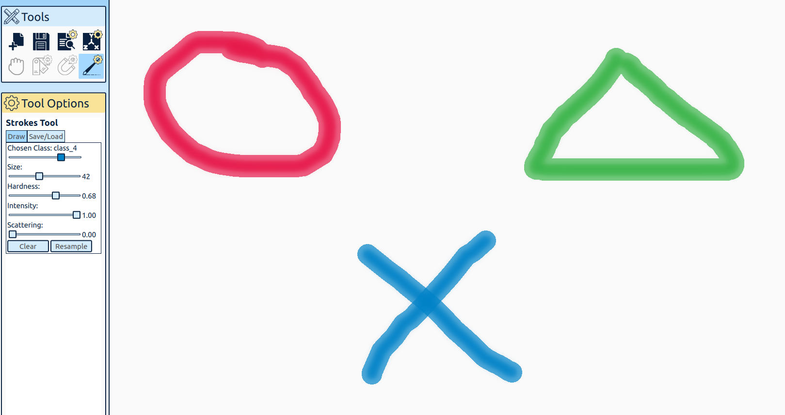
- Alternatively, you can import an image describing the sampling template of a class in “Save/Load” tab.
- Click “Resample” button to resample points according to this template.
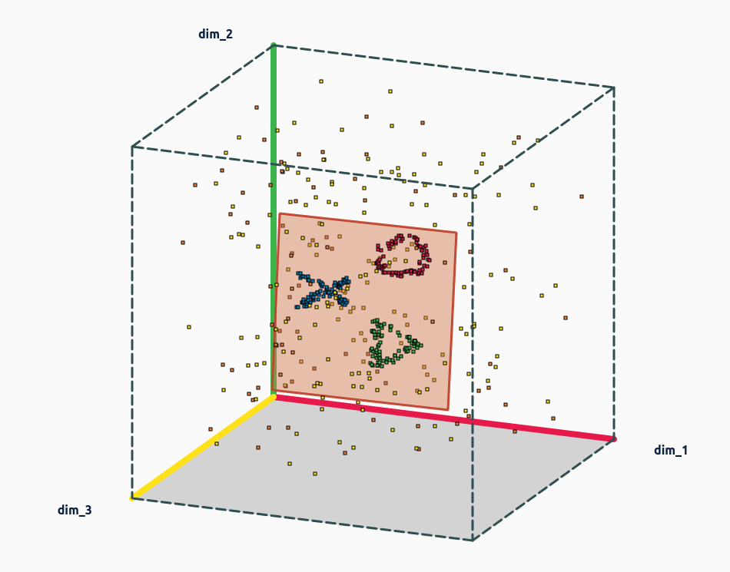

Step 5: Save Modified Dataset

- Click “Export Dataset” icon in “Tools” menu:
- In file dialog, navigate to the folder of your choice, give dataset a name and save it.
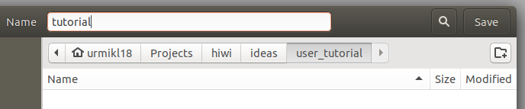
- Notice that this action produces two files: “tutorial.data” which contains dataset values, and “tutorial.data.json” which contains dataset’s metadata like dimension names, scales etc.


